In all programming languages, memory allocation and deallocation are an important aspect. Any unused memory should be deallocated otherwise it may lead to a shortage of memory and can generate an "out of memory" error.

As we have already learned about Reference type, writing "Account account = new Account()" creates a new object. The purpose of the new keyword is to allocate memory.
- Stack memory and Heap memory is the two divisions in which memory is allocated to a Java application.
- Stack memory contains all the local variables, local references, and method invocations.
- All objects and arrays are stored in the heap memory.
- All instance variables within an object are stored in the heap as part of the memory allocated to that object.
What if an application does not free the unused memory it occupies? Is there some way to de-allocate memory?
The automatic de-allocation of the memory is done by the garbage collector in Java.
The garbage collector will free memory occupied by an object under three conditions:
- When the reference of the object is set to null.
- When the reference of the object is set to some new object such that no reference points to the previous object. In this class, the un-referenced previous object will be garbage collected.
- When a reference is local to some method then it will be removed from the Stack as soon as the method is executed. If this reference is pointing to an object, that object will also be garbage collected.

Can you tell me how many objects are eligible for garbage collection after executing line 4?

- public class Customer {
- private String name;
- private String customerId;
- public Customer(String name, String customerId) {
- this.name = name;
- this.customerId = customerId;
- }
- public static void main(String[] args) {
- Customer customer1 = new Customer("Ajay","12");
- Customer customer2 = new Customer("Vijay","13");
- Customer customer3 = customer2;
- customer1 = customer3 = null; //line 4
- }
- }

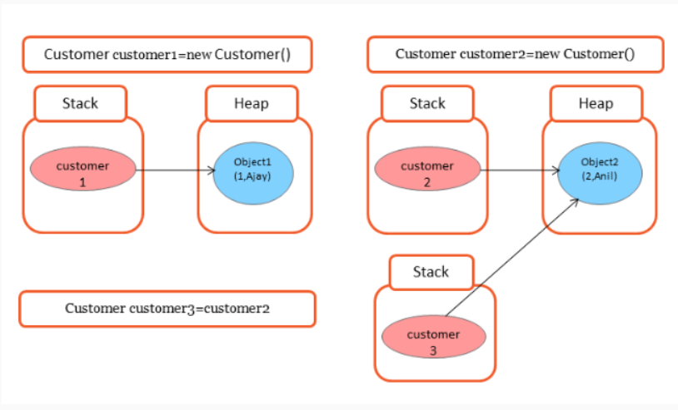

As you know in Java we have three different scopes of variables. Let me explain at what time they are deallocated when used in the program. Based on that you can avoid unnecessary wastage of memory.
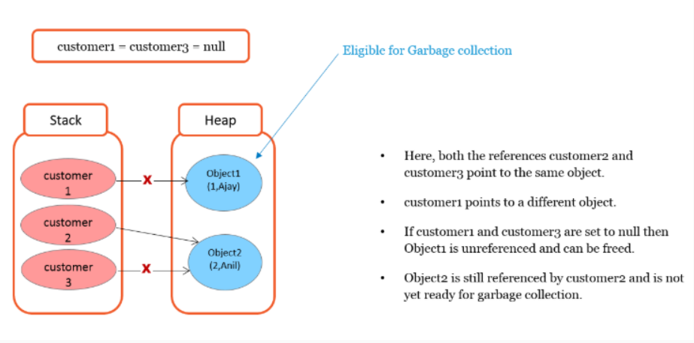
In Java, memory is primarily divided into three parts: Stack Memory, Heap Memory, and Method Area (part of the non-heap memory).
1. Stack Memory: Stack memory is used for execution of a thread. It contains method references, local variables, and reference variables. Each method call creates a new block in the stack memory for method variables. Once the method execution is done, it will be removed from the stack. The stack memory size is very limited compared to the heap memory.
2. Heap Memory: Heap memory is used for dynamic memory allocation for Java objects and JRE classes at runtime. New objects are always created in heap memory and the references to these objects are stored in stack memory. Heap memory is larger compared to stack memory.
3. Method Area (Non-Heap Memory): This is where class data gets stored, such as runtime constant pool, field and method data, and the code for methods and constructors. It is part of the non-heap memory. Static variables and static methods are also stored in this part of the memory.
In summary:
- Local variables are stored in Stack Memory.
- Objects and their instance variables are stored in Heap Memory.
- Class level information (like class names, static variables, and the bytecode of methods) is stored in the Method Area.

